Overview:

* Throw in accuracy was 100% | Opponents throw in accuracy was 84.21%
* Defensive duels win percentage was only at 50% a 20% drop from Air Force and 10% of of season average
* Only 82 Offensive duels we weren’t getting forward as much as previous games
* Pass accuracy into final third was only 40% which is 20% less than season average of (60.38%)
* Struggled to penetrate the ball on the left side despite having more passes on the left
  + 42% of passes on left | 38.0% on right
  + 31% of attacking third breakthrough passes on left | 54% of attacking third breakthrough passes on right
  + Carter struggled to penetrate the other team’s half
* 75% of opponents' chances came off 2nd balls or turnovers on UCSD’s left flank.
* 58% of Navy’s chances involved 4+ passes
* First game most of our losses were misplaced passes (55%)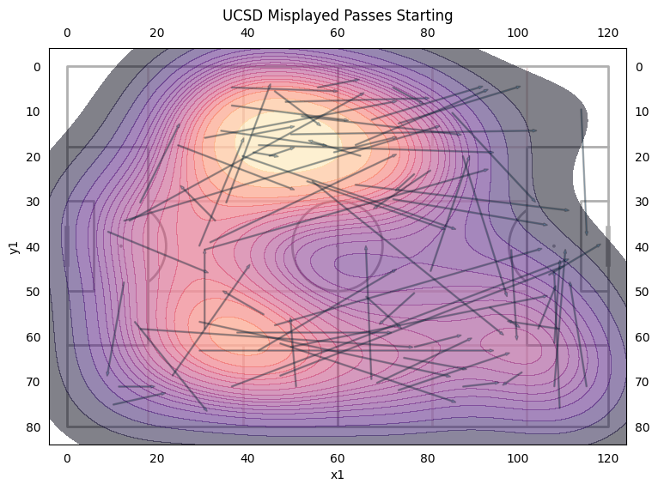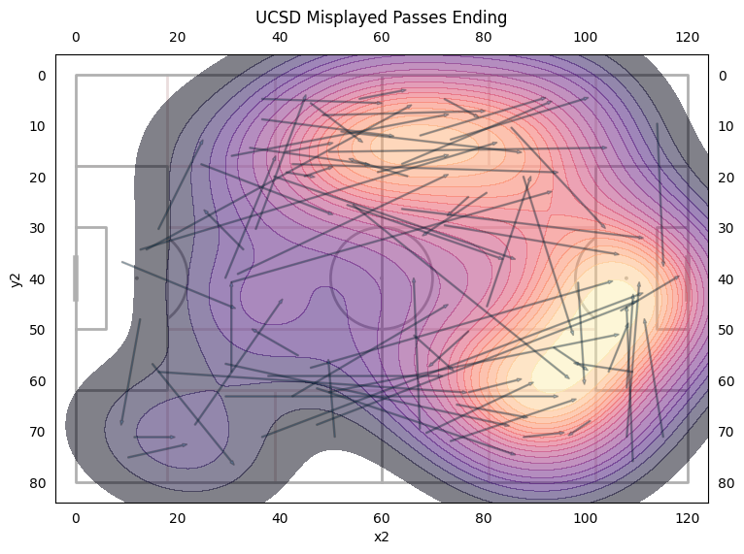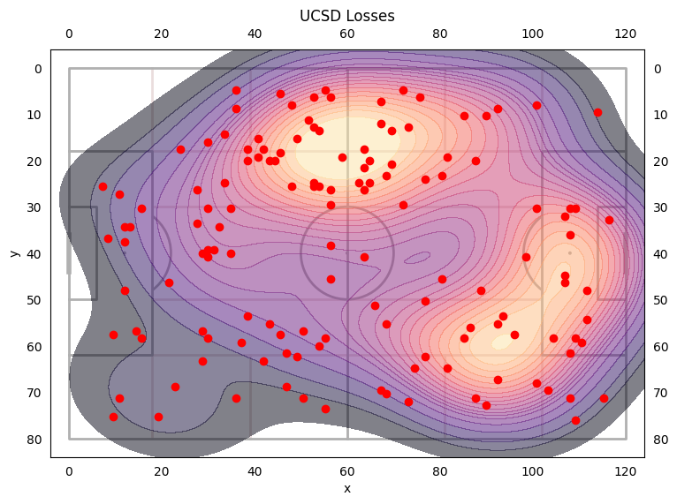
* 54.7% of losses are on the left
* 45.3% of losses are on the right
* Max, Jonah, and Quinn had the most losses at 15. Then Evan at 14 and James at 13.
* Defensive duels accuracy was 50% while our season average is current 61.9%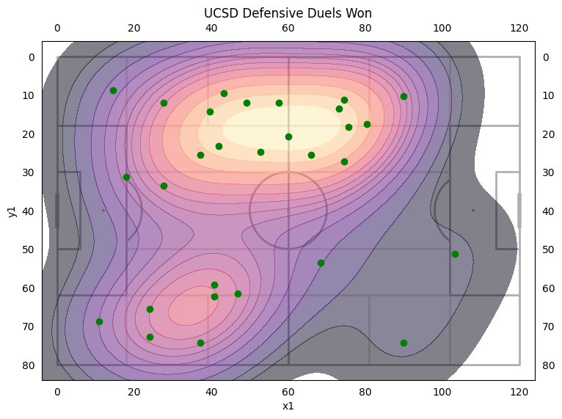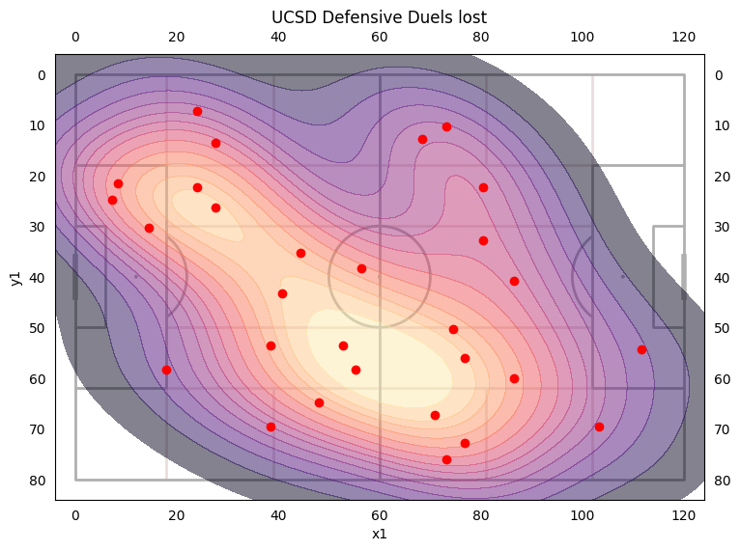
* 20% drop from Air Force
* Highest winning players: Michael (2/2), Adam (7/11), Carter (⅔), Jonah (⅗)
* Lowest winning players: Woody (¼), Ryan (⅓), Brian (⅖)
* Offensive duels accuracy was 37.8% while our season average was 37.3%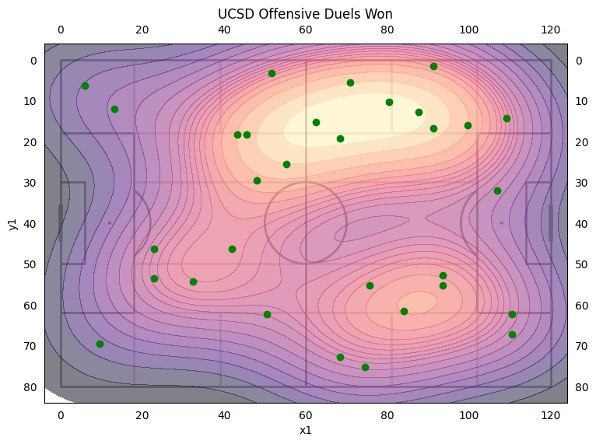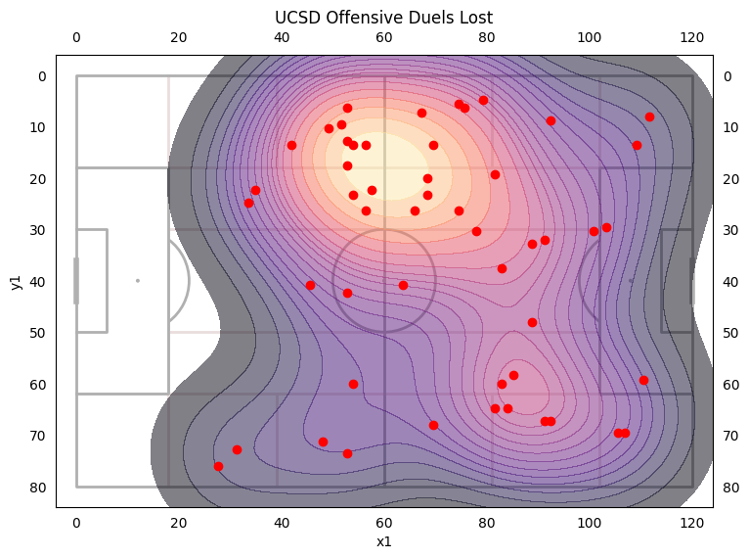
* Only 82 Offensive duels which is a drop of 40 from Air Force and 10 less than 91.25 avg
* Majority of offensive duels are on the left side
* The right side won 8% more of their offensive duels
* Highest winning players: Cole (3/3), Woody (2/2), Matt (2/2), Carter (4/6), McGee (4/8), Kai (5/11)
* Lowest winning players: Ryan (0/2), Max (1/10), Jonah (1/7), Michael (⅙), Brian (2/9), Quinn (3/10)
* Forward pass accuracy was 69.23% which is 2% higher than season average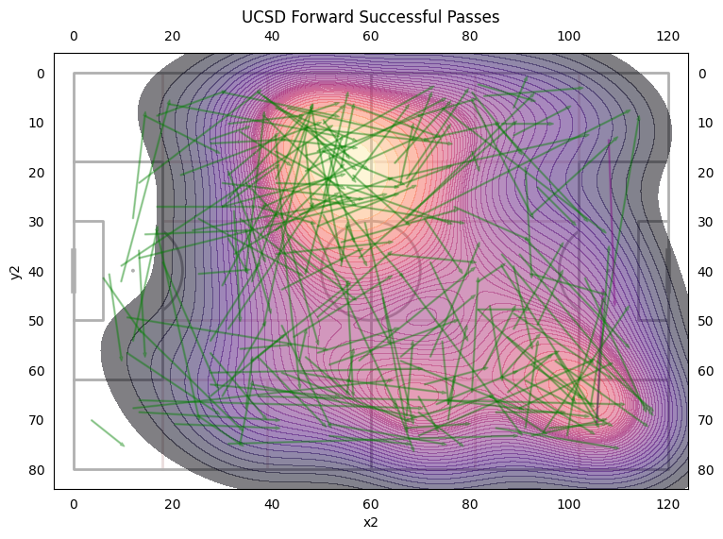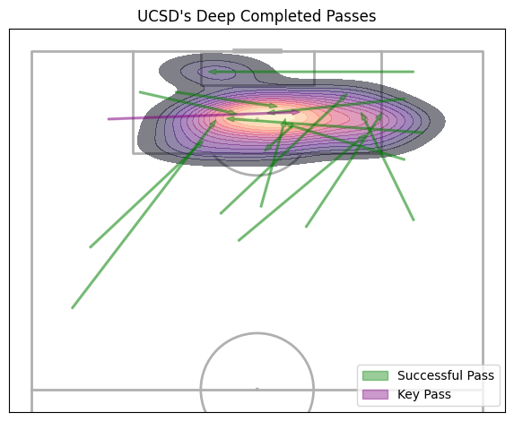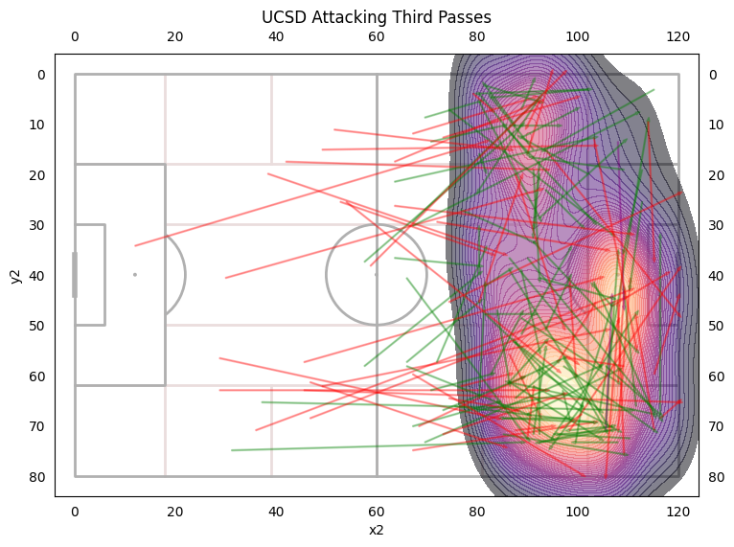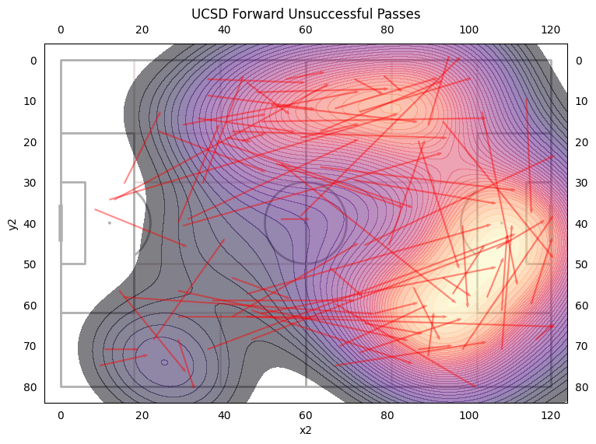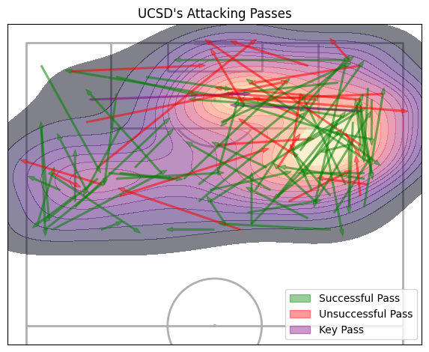
* 42% of forward passes were on the left | 38.9% of forward passes were on the right | 18.4% of forward passes were a switch
* Only 31% of successful passes into attacking third were from left side while 53.5% of successful passes into attacking third were from right side
* UCSD had 15 passes into the opponent's box.
* Carter struggled to pass the ball to break into opponents half

